# FMX Mobile Application Development

## Lab Exercise: 03.07 Tab Components to Display Pages on both iOS and Android.

Tabs are defined by [**FMX.TabControl.TTabControl**](http://docwiki.embarcadero.com/Libraries/en/FMX.TabControl.TTabControl), which is a container that can hold several tab pages. Each tab page can contain any control as a UI element. You can hide the tab for these pages, and change pages without showing tabs.

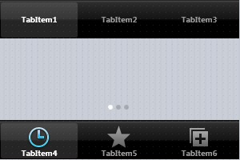

For each tab, you can specify:

* A text label — for both iOS and Android
* Predefined icons — for iOS only
* Custom icons — for both iOS and Android

## Using the Native Style for Tabs on iOS and Android

This Lab Exercise shows tabs with the same style on both iOS and Android, but this practice is not recommended.   
We recommend that you observe the native style of each platform, as follows:

**On Android:**

* Tabs are commonly placed at the top of the screen (so you should set [TTabPosition](http://docwiki.embarcadero.com/Libraries/en/FMX.TabControl.TTabPosition) either to **Top** or to **PlatformDefault**).
* Tabs traditionally display only text. However, FireMonkey allows you to specify custom icons to be displayed on tabs (see [Using Custom Multi-Resolution Icons for Your Tabs](http://docwiki.embarcadero.com/RADStudio/en/Mobile_Tutorial:_Using_Tab_Components_to_Display_Pages_(iOS_and_Android)#Using_Custom_Multi-Resolution_Icons_for_Your_Tabs)).

**On iOS:**

* Tabs are typically shown at the bottom of the screen (so you should set [TTabPosition](http://docwiki.embarcadero.com/Libraries/en/FMX.TabControl.TTabPosition) either to **Bottom** or to **PlatformDefault**).
* Tab items always display both text and an icon, which can be set via the [StyleLookup](http://docwiki.embarcadero.com/Libraries/en/FMX.TabControl.TTabItem.StyleLookup) property for each tab.

**Note:** You can use the **PlatformDefault** value of the [TTabPosition](http://docwiki.embarcadero.com/Libraries/en/FMX.TabControl.TTabPosition) enumeration to set the tab position according to the default behavior of the target platform. When **PlatformDefault** is set for [TTabPosition](http://docwiki.embarcadero.com/Libraries/en/FMX.TabControl.TTabPosition):

* In iOS apps, tabs are aligned at the lower edge of the [TTabControl](http://docwiki.embarcadero.com/Libraries/en/FMX.TabControl.TTabControl).
* In Android apps, tabs are aligned at the top edge of the [TTabControl](http://docwiki.embarcadero.com/Libraries/en/FMX.TabControl.TTabControl).

## Designing Tab Pages Using the Form Designer

To create tab pages in your application, use the [**TTabControl**](http://docwiki.embarcadero.com/Libraries/en/FMX.TabControl.TTabControl) component with the following steps:

1. Select:
   * For Delphi: **File > New >**[**Multi-Device Application**](http://docwiki.embarcadero.com/RADStudio/en/Multi-Device_Application)**- Delphi >**[**Blank Application**](http://docwiki.embarcadero.com/RADStudio/en/HD_Multi-Device_Application)
   * For C++: **File > New >**[**Multi-Device Application**](http://docwiki.embarcadero.com/RADStudio/en/Multi-Device_Application)**- C++Builder >**[**Blank Application**](http://docwiki.embarcadero.com/RADStudio/en/HD_Multi-Device_Application)
2. Select [**TTabControl**](http://docwiki.embarcadero.com/Libraries/en/FMX.TabControl.TTabControl) from the [Tool Palette](http://docwiki.embarcadero.com/RADStudio/en/Tool_Palette):

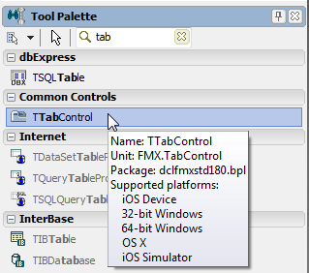

3. After you drop the **TTabControl**, an empty **TabControl** is shown on the [Form Designer](http://docwiki.embarcadero.com/RADStudio/en/Form_Designer) (you might need to manually adjust the position of the TabControl):

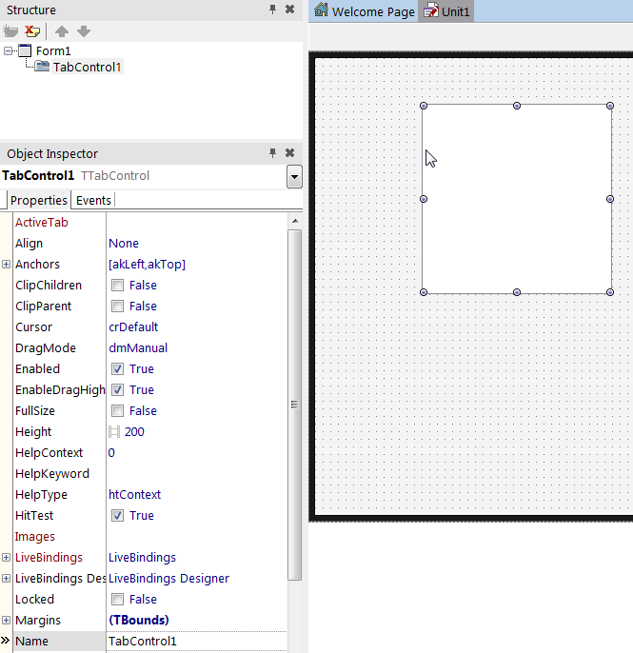

4. Typically, applications that use TabControl use the full screen to show pages.   
To do this, you need to change the default alignment of TabControl. In the [Object Inspector](http://docwiki.embarcadero.com/RADStudio/en/Object_Inspector), change the **Align** property of TabControl to **Client**:

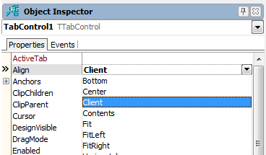

5. Right-click the TabControl, and select Items Editor... from the context menu:

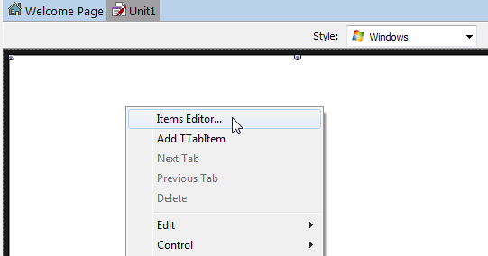

6. Click **Add Item** three times, so that now you have three instances of [TabItem](http://docwiki.embarcadero.com/Libraries/en/FMX.TabControl.TTabItem) here. Close the dialog box.

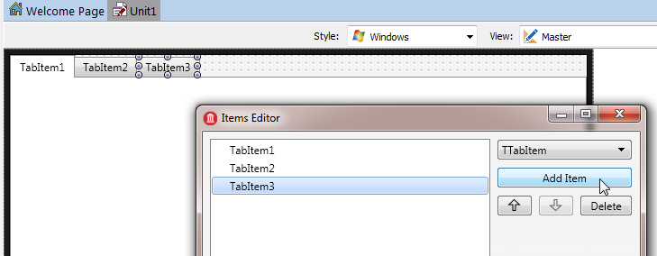

7. On the [Form Designer](http://docwiki.embarcadero.com/RADStudio/en/Form_Designer), select the first TabItem and change its **StyleLookup** property to **tabitembookmarks** for **iOS Style**:

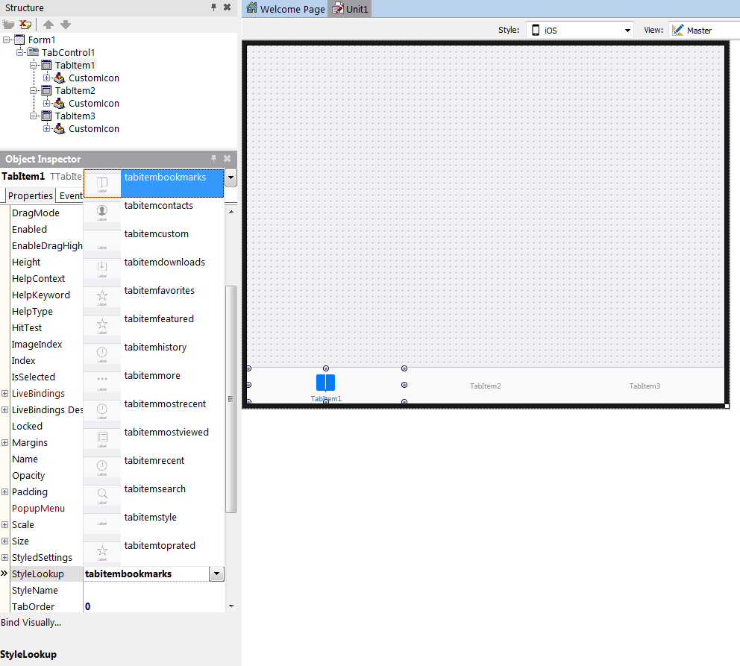

8. And for Android Style, on the [Form Designer](http://docwiki.embarcadero.com/RADStudio/en/Form_Designer), select the first TabItem and change its **StyleLookup** property to **tabitemstyle** :

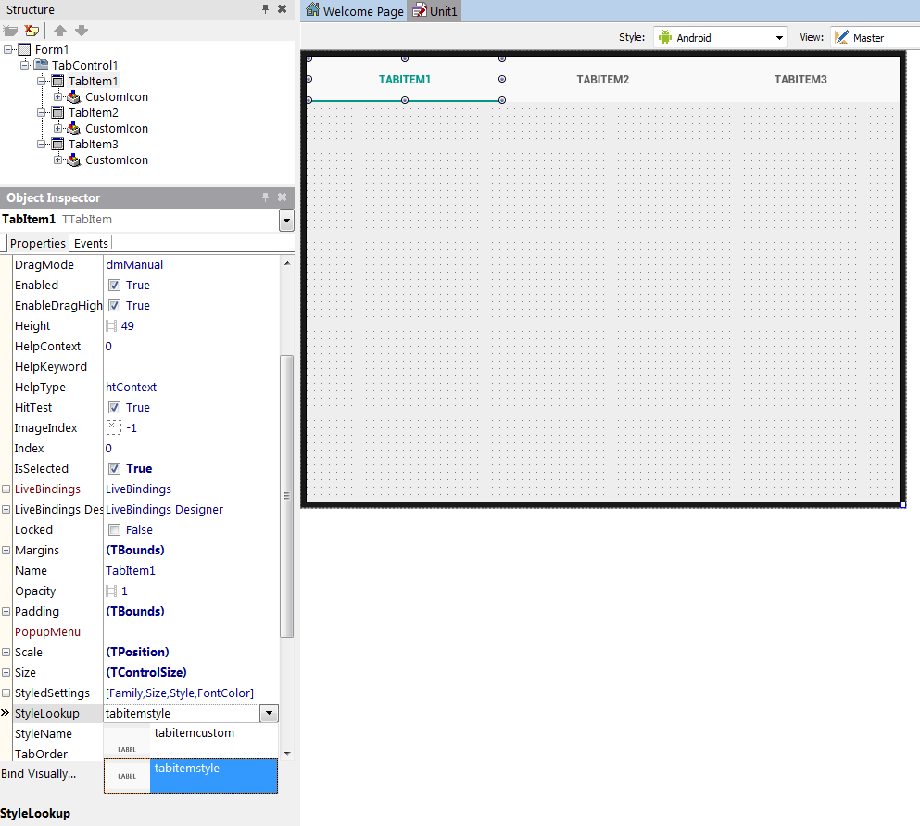

9. You can place any component on each page.   
To move to a different page, just click the tab you want on the Form Designer, or change the [**ActiveTab**](http://docwiki.embarcadero.com/Libraries/en/FMX.TabControl.TTabControl.ActiveTab) property in the [Object Inspector](http://docwiki.embarcadero.com/RADStudio/en/Object_Inspector):

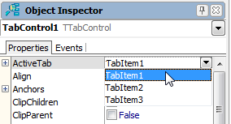

10. To change the location of tabs, select the [**TabPosition**](http://docwiki.embarcadero.com/Libraries/en/FMX.TabControl.TTabControl.TabPosition) property for the TabControl component, and set it to one of the following values in the [Object Inspector](http://docwiki.embarcadero.com/RADStudio/en/Object_Inspector):

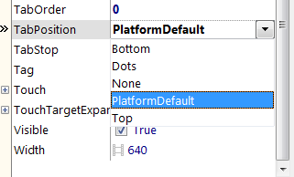

## Comparing the Tab Settings on iOS and Android

The following figures show both apps with the same [**TabPosition**](http://docwiki.embarcadero.com/Libraries/en/FMX.TabControl.TTabControl.TabPosition) settings (**Top**, **Bottom**, **Dots**, and **None**) on iOS and Android.   
However, you should set the appropriate different tab settings for each mobile platform, as indicated in [#Using the Native Style for Tabs on iOS and Android](http://docwiki.embarcadero.com/RADStudio/en/Mobile_Tutorial:_Using_Tab_Components_to_Display_Pages_(iOS_and_Android)#Using_the_Native_Style_for_Tabs_on_iOS_and_Android).

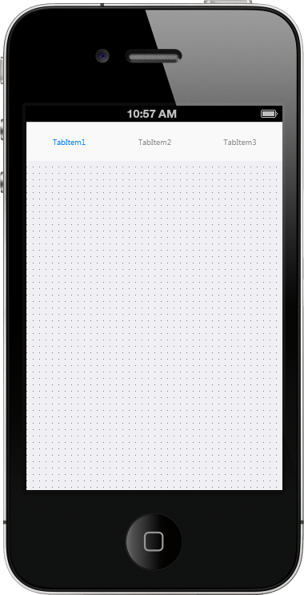 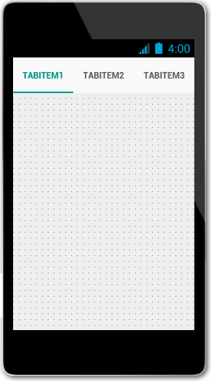

## Using Custom Multi-Resolution Icons for Your Tabs

You can use custom multi-resolution icons as well as custom text on tabs in your application.   
These steps shows you how to construct the following three tabs that have custom icons and text:

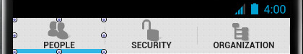

**Notes:**

* In **Android** apps, predefined icons are not supported, so you must use custom icons.
* In **iOS** apps, you can use either predefined icons or custom icons.
* To use custom icons on either iOS or Android, select the appropriate iOS or Android **Style** in the [Form Designer](http://docwiki.embarcadero.com/RADStudio/en/Form_Designer), set the **StyleLookup** property of [TTabItem](http://docwiki.embarcadero.com/Libraries/en/FMX.TabControl.TTabItem.Align) to **tabitemcustom**, specify your custom icon as described in this section, and then build your app.
* For iOS, you can use our predefined icons by setting the **StyleLookup** property of [TTabItem](http://docwiki.embarcadero.com/Libraries/en/FMX.TabControl.TTabItem.Align) to the icon of your choice, such as TabItemSearch.png (**tabitemsearch**).
* The custom glyphs used in this section are available in a zip file that is delivered in your C:\Program Files (x86)\Embarcadero\Studio\20.0\Images\GlyFX directory.   
  The three PNGs used here are located in the Icons\Aero\PNG\32x32 directory:
  + **users_32** (People)
  + **unlock_32** (Security)
  + **tree_32** (Organization)

Unzip the **glyFX.zip** file before you use the MultiResBitmap Editor if you want to use these images or any others available in the GlyFX collection.

## Displaying Multi-Resolution Custom Icons on Tabs

1. In the [Object Inspector](http://docwiki.embarcadero.com/RADStudio/en/Object_Inspector), select **TabItem1**, and then change the tab caption, which is specified in the [Text](http://docwiki.embarcadero.com/Libraries/en/FMX.TabControl.TTabItem.Text) property to **People**; change the **Text** property of **TabItem2** to **Security**, and **TabItem3** to **Organization**.

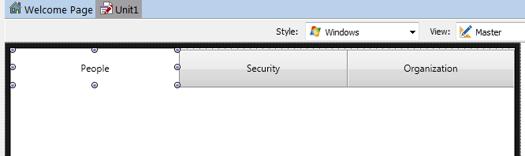

2. Select a tab, and click the ellipsis button [...] on the [**CustomIcon**](http://docwiki.embarcadero.com/Libraries/en/FMX.TabControl.TTabItem.CustomIcon) property of TTabItem in the [Object Inspector](http://docwiki.embarcadero.com/RADStudio/en/Object_Inspector):

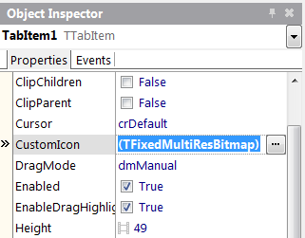

3. The [**MultiResBitmap Editor**](http://docwiki.embarcadero.com/RADStudio/en/MultiResBitmap_Editor) opens:

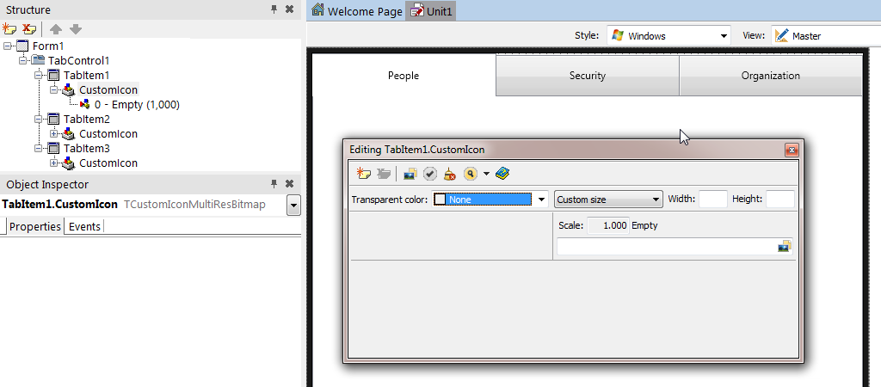

4. Ensure that you are in the Master view, and in the MultiResBitmap Editor, click the array next to **Custom size**, and then choose **Default size**.

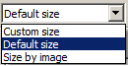

5. Repeat the following steps to add any additional scales that you want to support:

1. In the MultiResBitmap Editor, click New.png (**Add new item**).
2. Enter the additional Scale you want to support, such as 1.5, 2, or 3.
   * When you have added all the scales you want, the editor looks like this:

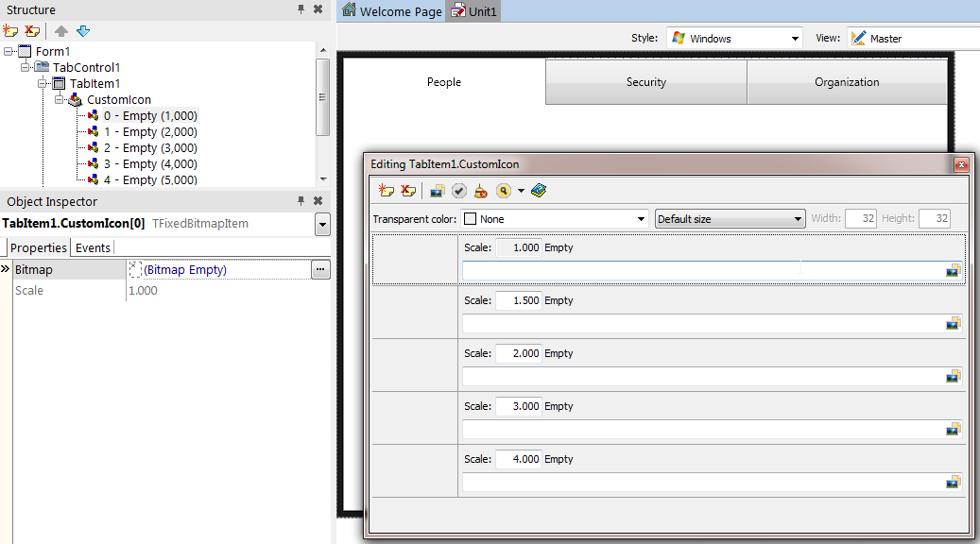

6. Click the **Fill All from File** button MResBMPFill.png, navigate to an image file you want to use, and then click **Open**.

The selected image now appears appropriately scaled in each of the Scale entries on the MultiResBitmap Editor:

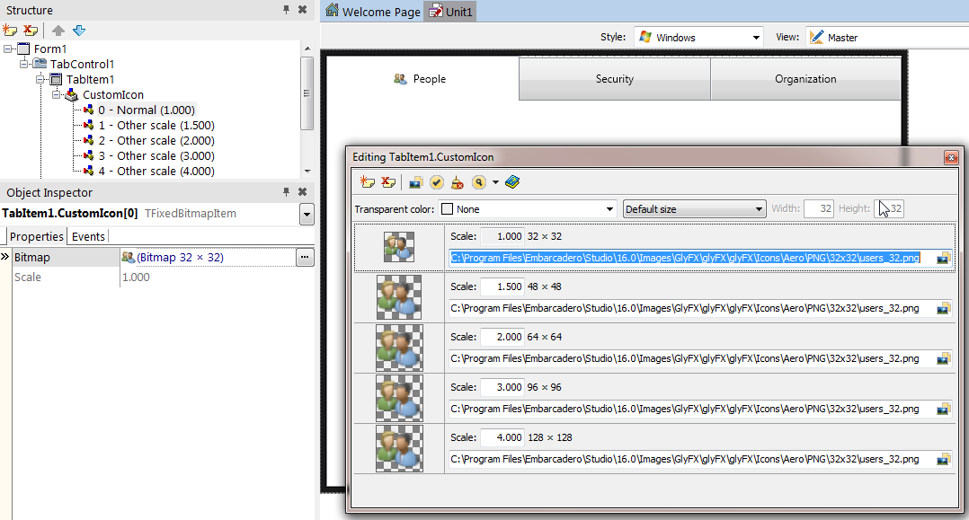

7. Close the MultiResBitmap Editor.

8. Repeat Steps 2 to 7 for each of the remaining tabitems, and assign each tabitem a custom icon image.

After you define a custom icon, the FireMonkey framework generates a **Selected Image** and **Non-Selected (dimmed) Image** based on the given .png file. This transformation is done using the Alpha-Channel of the bitmap data. For example:

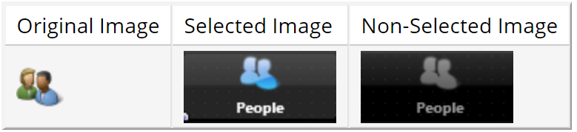

## Using a Single-Resolution Bitmap for a Custom Icon

You can also use only a single-resolution bitmap by using the [**Bitmap Editor**](http://docwiki.embarcadero.com/RADStudio/en/Bitmap_Editor). A single-resolution bitmap displays only one scale in the Structure View:

SingleResBitmapInStructureView.png

To specify a single-resolution bitmap for a custom icon, perform the [first step of the procedure above](http://docwiki.embarcadero.com/RADStudio/en/Mobile_Tutorial:_Using_Tab_Components_to_Display_Pages_(iOS_and_Android)#Using_Custom_Multi-Resolution_Icons_for_Your_Tabs) and then proceed as follows:

1. In the [Structure View](http://docwiki.embarcadero.com/RADStudio/en/Structure_View), select **Empty** under CustomIcon:

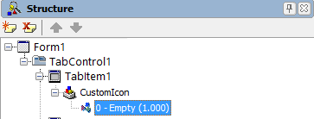

1. Now, in the [Object Inspector](http://docwiki.embarcadero.com/RADStudio/en/Object_Inspector), click the ellipsis button [...] in the **Bitmap** field (of the [TabItem1.CustomIcon[0]](http://docwiki.embarcadero.com/Libraries/en/FMX.MultiResBitmap.TFixedBitmapItem)). This opens the [**Bitmap Editor**](http://docwiki.embarcadero.com/RADStudio/en/Bitmap_Editor):

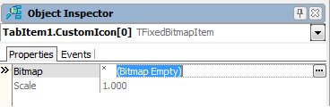

1. In the [**Bitmap Editor**](http://docwiki.embarcadero.com/RADStudio/en/Bitmap_Editor), click the **Load...** button, and select a PNG file.   
   The recommended size is 30x30 pixels for normal resolution, and 60x60 pixels for high resolution:

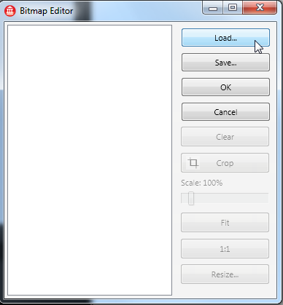

1. Click **OK** to close the **Bitmap Editor**.
2. In the [Object Inspector](http://docwiki.embarcadero.com/RADStudio/en/Object_Inspector), set the **StyleLookup** property to be **tabitemcustom**:

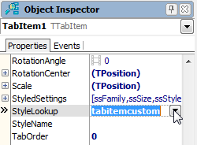

Defining Controls within a TabControl

As discussed, each Tab Page can contain any number of controls including another TabControl. In such a case, you can easily browse and manage different tab pages in the [Structure View](http://docwiki.embarcadero.com/RADStudio/en/Structure_View):

|  |
| --- |
| **iOS** |
| TabControlCanContainAnotherTabControl.png |
|  |

|  |
| --- |
| **Android** |
| AndroidTabControlCanContainAnotherTabControl.png |

## Changing the Page at RunTime

### By the User Tapping the Tab

If Tabs are visible (when the [TabPosition](http://docwiki.embarcadero.com/Libraries/en/FMX.TabControl.TTabControl.TabPosition) property is set to other than None), an end user can simply tap a Tab to open the associated page.

### By Actions and an ActionList

An [action](http://docwiki.embarcadero.com/RADStudio/en/FireMonkey_Actions) corresponds to one or more elements of the user interface, such as menu commands, toolbar buttons, and controls. Actions serve two functions:

* Actions represent properties common to the user interface elements, such as whether a control is enabled or whether a checkbox is selected.
* Actions respond when a control fires, for example, when the application user clicks a button or chooses a menu item.

Here are the steps to enable a user to move to different tab pages by clicking a button:

1. On the [Form Designer](http://docwiki.embarcadero.com/RADStudio/en/Form_Designer), click **TabItem1** to select it.
2. From the [**Tool Palette**](http://docwiki.embarcadero.com/RADStudio/en/Tool_Palette), add a [**TActionList**](http://docwiki.embarcadero.com/Libraries/en/FMX.ActnList.TActionList) component to the form, and then add a [TButton](http://docwiki.embarcadero.com/Libraries/en/FMX.StdCtrls.TButton) to **TabItem1**:

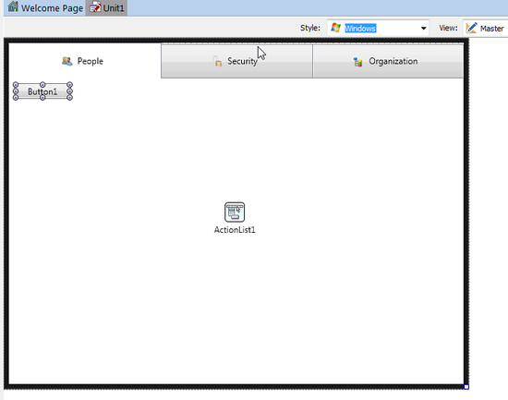

1. With the button selected, in the [Object Inspector](http://docwiki.embarcadero.com/RADStudio/en/Object_Inspector), select **Action | New Standard Action | Tab >**[**TChangeTabAction**](http://docwiki.embarcadero.com/Libraries/en/FMX.TabControl.TChangeTabAction) from the drop-down menu. After the user clicks this button, the action you just defined is performed (the tab page changes):

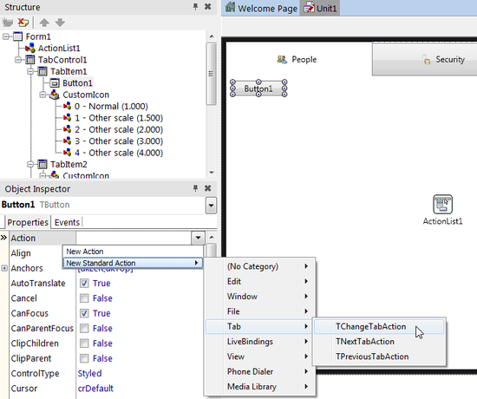

1. Select **ChangeTabAction1** in the [Structure View](http://docwiki.embarcadero.com/RADStudio/en/Structure_View), and then select **TabItem2** for the **Tab** property in the Object Inspector. By linking to **TabItem2**, this action can change the page to **TabItem2**:

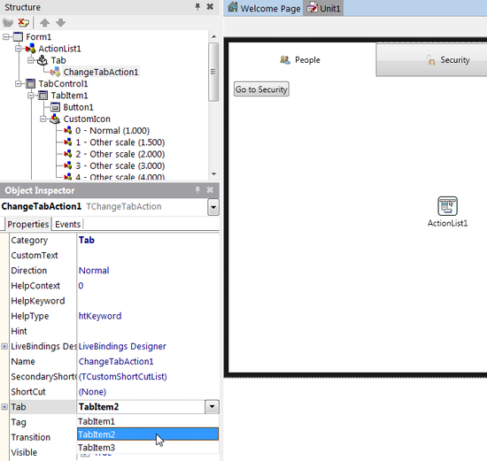

1. With the previous step, the caption (the Text property) of the button is automatically changed to "Go To Security" because the caption of **TabItem2** is "Security" in our example. Set the [**CustomText**](http://docwiki.embarcadero.com/Libraries/en/FMX.TabControl.TChangeTabAction.CustomText) property of the **ChangeTabAction1** component to **Security** as shown below and change the size of the button to fit the new caption text, if required.

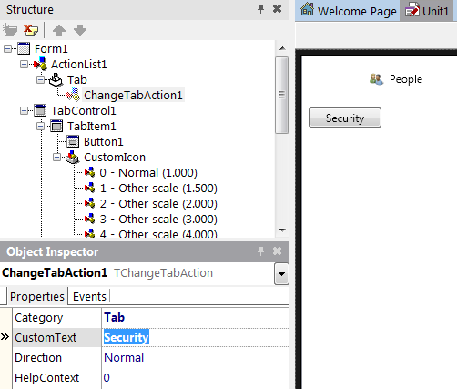

1. ChangeTabAction also supports the **Slide** animation to indicate a transition between pages. To use it, set the [**Transition**](http://docwiki.embarcadero.com/Libraries/en/FMX.TabControl.TChangeTabAction.Transition) property to **Slide**:

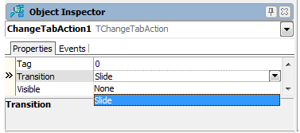

1. On the Form Designer, select **TabItem2** and drop two TButtons from the Tool Palette to **TabItem2**.
2. On the Form Designer, select **Button2** and in the Object Inspector, select **Action | New Standard Action | Tab >**[**TPreviousTabAction**](http://docwiki.embarcadero.com/Libraries/en/FMX.TabControl.TPreviousTabAction) from the drop-down menu.
3. On the Form Designer, select **Button3** and in the Object Inspector, select **Action | New Standard Action | Tab >**[**TNextTabAction**](http://docwiki.embarcadero.com/Libraries/en/FMX.TabControl.TNextTabAction) from the drop-down menu.
4. Select **PreviousTabAction1** in the Structure View and in the Object Inspector, set its [TabControl](http://docwiki.embarcadero.com/Libraries/en/FMX.TabControl.TPreviousTabAction.TabControl) property to **TabControl1**.
5. Select **NextTabAction1** in the Structure View and in the Object Inspector, set its [TabControl](http://docwiki.embarcadero.com/Libraries/en/FMX.TabControl.TPreviousTabAction.TabControl) property to **TabControl1**.

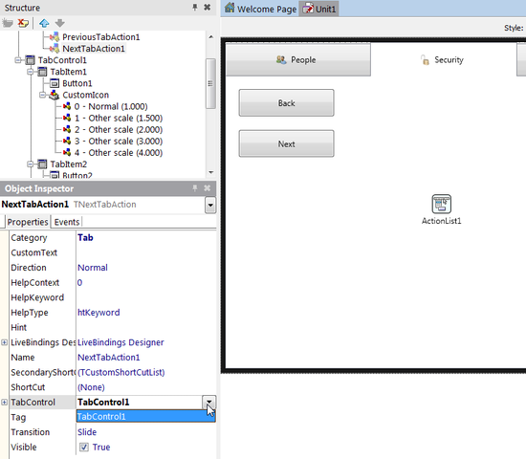

1. On the Form Designer, select **TabItem3** and drop a TButton from the Tool Palette to **TabItem3**.
2. In the Object Inspector, set the [Action](http://docwiki.embarcadero.com/Libraries/en/FMX.StdCtrls.TButton.Action) property of the button to **PreviousTabAction1**.

## By Source Code

You can use any of the following three ways to change the active tab page from your source code, by clicking the button.

Assign an Instance of [TTabItem](http://docwiki.embarcadero.com/Libraries/en/FMX.TabControl.TTabItem) to the [ActiveTab](http://docwiki.embarcadero.com/Libraries/en/FMX.TabControl.TTabControl.ActiveTab) Property

1. From the Tool Palette, add a [TButton](http://docwiki.embarcadero.com/Libraries/en/FMX.StdCtrls.TButton) to **TabItem3**.
2. In the Object Inspector, set its **Text** property to **Go To People**.

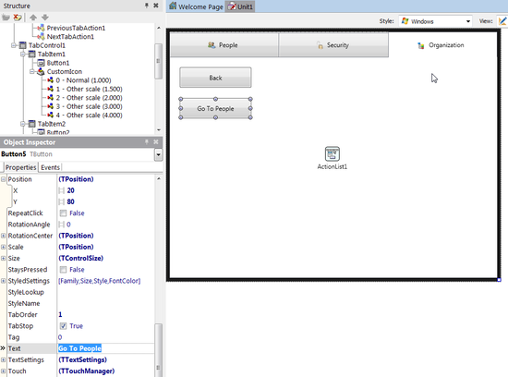

1. On the Form Designer, double-click the button to create the [OnClick](http://docwiki.embarcadero.com/Libraries/en/FMX.StdCtrls.TButton.OnClick) event handler and add the following code:

**Delphi:**

TabControl1.ActiveTab := TabItem1;

**C++:**

TabControl1->ActiveTab = TabItem1;

## Change the [TabIndex](http://docwiki.embarcadero.com/Libraries/en/FMX.TabControl.TTabControl.TabIndex) Property to a Different Value

The TabIndex property is a zero-based Integer value. You can specify any number between 0 and TabControl1.TabCount - 1.

1. From the Tool Palette, add a [TButton](http://docwiki.embarcadero.com/Libraries/en/FMX.StdCtrls.TButton) to TabItem1.
2. In the Object Inspector, set its Text property to Go To Organization.

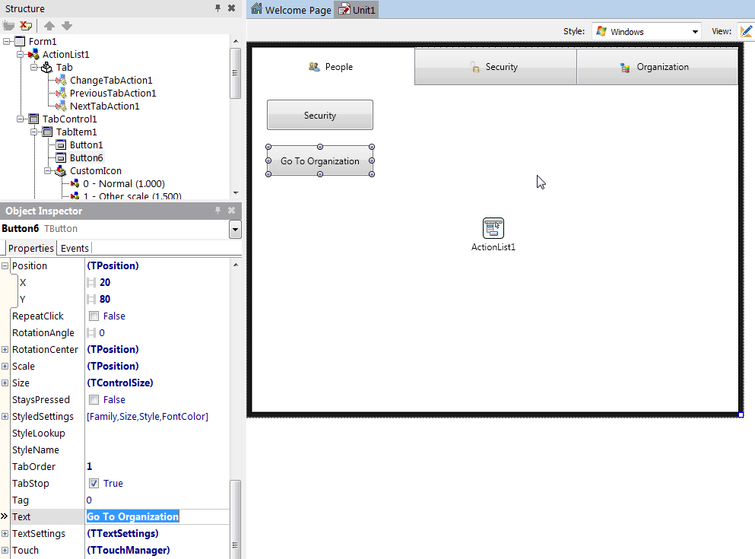

3. On the Form Designer, double-click the button to create the [OnClick](http://docwiki.embarcadero.com/Libraries/en/FMX.StdCtrls.TButton.OnClick) event handler and add the following code:

**Delphi:**

TabControl1.TabIndex := 2;

**C++:**

TabControl1->TabIndex = 2;

Call the [ExecuteTarget](http://docwiki.embarcadero.com/Libraries/en/FMX.TabControl.TChangeTabAction.ExecuteTarget) Method of a Tab Action

You can call the [ExecuteTarget](http://docwiki.embarcadero.com/Libraries/en/FMX.TabControl.TChangeTabAction.ExecuteTarget) method for any of the tab control actions ([TChangeTabAction](http://docwiki.embarcadero.com/Libraries/en/FMX.TabControl.TChangeTabAction), [TNextTabAction](http://docwiki.embarcadero.com/Libraries/en/FMX.TabControl.TNextTabAction), and [TPreviousTabAction](http://docwiki.embarcadero.com/Libraries/en/FMX.TabControl.TPreviousTabAction)). You must ensure to define the [TChangeTabAction.Tab](http://docwiki.embarcadero.com/Libraries/en/FMX.TabControl.TChangeTabAction.Tab), [TPreviousTabAction.TabControl](http://docwiki.embarcadero.com/Libraries/en/FMX.TabControl.TPreviousTabAction.TabControl) or the [TNextTabAction.TabControl](http://docwiki.embarcadero.com/Libraries/en/FMX.TabControl.TNextTabAction.TabControl) properties.

**Delphi:**

*// You can set the target at run time if it is not defined yet.*

ChangeTabAction1.Tab := TabItem2;

*// Call the action*

ChangeTabAction1.ExecuteTarget(**nil**);

**C++:**

*// You can set the target at run time if it is not defined yet.*

ChangeTabAction1->Tab = TabItem2;

*// Call the action*

ChangeTabAction1->ExecuteTarget(NULL);

This Lab Exercise gave you a detailed understanding on how to use the Tab Components to Display Pages on both iOS and Android.